High TPS System Design: E-Commerces

For e-commerce, “high TPS” usually means very high traffic on browse/search, and high transaction TPS on cart/checkout/order/payment/inventory (the parts that must be correct).

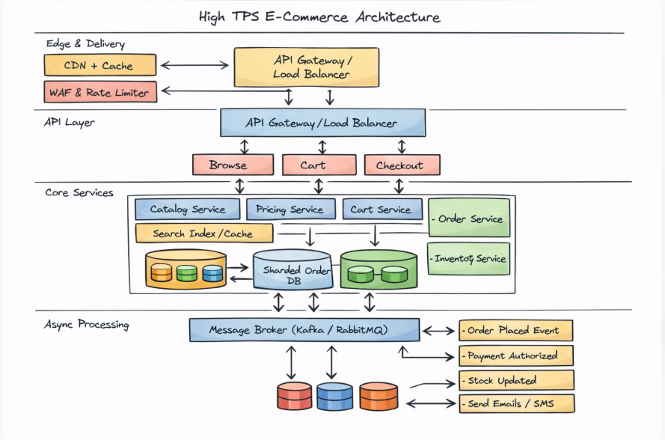

Below are the main things to take care of when you design it.
- Split the system by “read heavy” vs “write critical”
- A practical high-TPS e-commerce architecture
- Database & data modelling choices (make or break for TPS)
- Caching strategy (mandatory for e-commerce)
- Inventory correctness under high TPS (hard part)
- Payment & checkout: make everything idempotent
- Async processing to keep checkout fast
- Traffic spikes: backpressure and graceful degradation
- Observability: measure the right things
- A simple “golden path” flow (high TPS friendly)

1) Split the system by “read heavy” vs “write critical”
Read-heavy (huge QPS/TPS, can be eventually consistent):
- Home page, category pages, product detail page (PDP)
- Search, recommendations, reviews, pricing display (often cached)
Write/critical (lower TPS than reads, but correctness matters):
- Add-to-cart
- Checkout
- Place order
- Reserve/commit inventory
- Payment authorization/capture
- Refunds/returns
Design goal: let the read side scale like crazy without overloading the write side.

2) A practical high-TPS e-commerce architecture
Edge + delivery
- CDN for static assets and cached HTML/JSON
- WAF + bot protection + rate limiting at the edge
API layer
- API Gateway / Load balancer
- Stateless application services (scale horizontally)
Core services (typical split)
- Catalog service (product data)
- Pricing & promotions service
- Cart service
- Checkout service
- Order service
- Inventory service
- Payment service (external PSP integration)
- Shipping/fulfillment service
- Notification service
Async backbone
- Message broker / event stream (Kafka/RabbitMQ/SQS, etc.)
- Outbox pattern from DB → events (prevents “DB updated but event not published”)
The event-driven flow is common for high TPS order processing.

3) Database & data modeling choices (make or break for TPS)
a) “One DB per service” (or at least per domain)
Avoid one mega-database that becomes the bottleneck. Microservices-style separation is common here.
b) Partition/shard the write-heavy tables
For orders/payments/inventory reservations:
- shard by customer_id, order_id, or region
- avoid “hot keys” (e.g., all traffic for one popular SKU hitting one partition)
c) Use the right storage per workload
- Catalog/search: search index (Elasticsearch/OpenSearch/Solr) + cache
- Cart: fast KV store (Redis/DynamoDB/Cassandra-style) with TTL
- Orders/ledger: relational or strongly consistent store (needs auditability)
- Inventory: store that supports conditional updates / atomic compare-and-set

4) Caching strategy (mandatory for e-commerce)
Where caching helps most:
- category pages, PDP fragments, price snapshots, inventory “availability hints”
- search results pages (short TTL)
What not to “blindly” cache:
- final inventory truth at checkout
- payment state
Avoid common cache failures:
- cache stampede (many requests on miss) → use request coalescing/locks
- stale prices → versioned cache keys or short TTL + background refresh

5) Inventory correctness under high TPS (hard part)
You need a clear model:
Option A: “Reserve then commit” (common)
- Checkout asks inventory to reserve items (temporary hold with TTL)
- Payment authorized
- Order confirmed → inventory committed
- If payment fails / times out → reservation released
Techniques:
- atomic decrement with conditional write (no negative stock)
- per-SKU reservation counters to avoid oversell
- handle “hot SKU” with partitioning or token-bucket per SKU
Option B: “Oversell allowed + backorder”
Works for some businesses; simplifies TPS but changes customer promise.

6) Payment & checkout: make everything idempotent
High TPS means retries will happen (timeouts, network issues, user double-clicks).
Must-have patterns:
- Idempotency keys for: PlaceOrder, AuthorizePayment, CapturePayment, Refund
- Exactly-once is rare; design for at-least-once + dedupe
- Store a “request journal” keyed by idempotency key → return same result on retry.

7) Async processing to keep checkout fast
Don’t block the user on slow steps:
- email/SMS
- invoice generation
- loyalty points
- analytics events
- some fraud checks (unless mandatory)
Use events like:
- OrderPlaced
- PaymentAuthorized
- InventoryCommitted
- ShipmentCreated
This reduces synchronous coupling and helps survive spikes.

8) Traffic spikes: backpressure and graceful degradation
During flash sales:
- queue writes (order placement) if possible
- reject early with friendly errors when saturated (429 / “please retry”)
- degrade non-critical features:
  - recommendations off
  - review widgets off
  - lower image quality
  - reduce search facets

9) Observability: measure the right things
Track per-domain:
- TPS/QPS per endpoint (browse, cart, checkout, place-order)
- p95/p99 latency
- error rate by type (timeouts vs validation vs dependency failures)
- queue depth / consumer lag
- inventory reservation failure rate
- payment gateway latency + decline rates

10) A simple “golden path” flow (high TPS friendly)
- User browses (CDN + cache)
- Add to cart (KV store)
- Checkout:
  - reserve inventory (fast atomic)
  - authorize payment (idempotent)
  - create order record
  - publish OrderPlaced event (outbox)
- Async:
  - fraud, notifications, fulfillment, analytics

